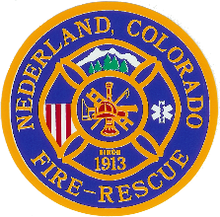 | Nederland Fire Protection District
Special Meeting of NFPD Board of Directors
April 22, 2020

- Roll Call: Henry Zurbrugg Chairman present via zoom
Ray Willis Treasurer present via zoom
Joe Evans Secretary absent
Nicholas Brodsky Director present via zoom
Beth Davis Director present via zoom
- Others present:
Rick Dirr NFPD Chief present via zoom

- Meeting called to order @ 1900

- Motion to approve Agenda:
Agenda Approved 4-0-0

- Please note this a special meeting, and regular line items will be addressed in the next regular Board Meeting on May 13th, 2020 @ 1900hrs.

- Review of Resolution 2020-002, to Extend the Declaration of Disaster for the Nederland Fire Protection District.

- Motion to Approve Resolution 2020-002

  - Approved 4-0-0

Meeting adjourned at 1911hrs.

Next Regular Meeting is May 13, 2020 @ 1900hrs.

