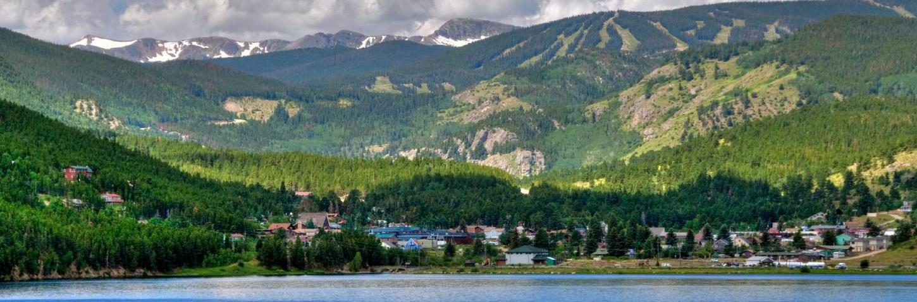
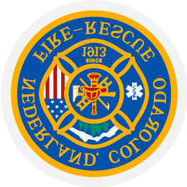
PRN Paramedic and PRN FF/Paramedic
Nederland, Colorado
Hiring Range: $28-32/hr. DOQ/EXP
Apply at www.NFPD.org

The Position
The Nederland Fire Protection District is pleased to announce our search for PRN Paramedics or FF/Paramedics. This position requires expert level competence and self-sufficiency as an EMS provider. The main roll for this position is as back fill for ALS command staff. While on duty, the NFPD Paramedic provides front line ALS support and guidance for approximately 25 volunteer emergency response professionals. The NFPD Paramedic is often the sole ALS first response provider in a mixed transport system, with private ALS ambulance transport provided by AMR Boulder. This position requires operating in a rugged mountain environment and variable weather conditions.

During normal business hours, the station is staffed with the Chief Staff, Shift Captain, and administrative staff. On weekends and evenings, the PRN Paramedic or FF/Paramedic may the only career staff member present, accompanied by a varying level of shifted and community-based responders.
The Community
The Town of Nederland occupies approximately 1.5 square miles on the eastern aspect of the front range, 18 miles west of Boulder, CO sitting at 8,240 feet above sea level. The Town has a rich and rugged mining history, coupled with a laidback mountain attitude. Its current population is 1,500, with an additional 3,000 living in the fire district boundaries. We are the gateway to the Eldora Ski Resort, seeing over 250,000 annual visitors, as well as to the Indian Peaks Wilderness area, which sees a vast number of outdoor enthusiasts. Numerous special events are associated with the Town, including Frozen Dead Guy Days, music festivals, and various athletic events. Special event standby and response are regular responsibilities for NFPD.
The Organization
The Nederland Fire Protection District averages approximately 430 calls per year and serves a 56 square mile area, including the Town of Nederland, The Eldora Ski Area, and a vast expanse of public lands.
In addition, there are numerous special events, support of wildfire mitigation activities, public education, and non-emergent requests for our expertise.
The Ideal Candidate
The district is seeking a candidate who must not only be technically proficient in EMS skills, but also value small town dynamics.
Competencies and Personal Characteristics
- Excellent communicator.
- A non-autocratic, participative leader, with strong interpersonal skills.
- A reputation for honesty and trustworthiness, approachability, and dependability.
- An expertly skilled and experienced ALS provider with a proven ability to effectively operate in complex situations with limited resources.
- An effective medical educator with a proven background of successfully mentoring BLS and ALS providers.
- Displays the ability to function independently, while also being able to function in a team-based, collaborative environment incorporating experience and professional judgment to best serve the community.
Required:
- 21 years of age or greater.
- Maintain a current, unrestricted Colorado Driver’s license and good driving record.
- Is a US Citizen or shows proof of authorization to work in the United States.
- Passes a criminal background check with no felony convictions or significant misdemeanor offenses as determined by employer
- Passes a physical examination including drug screen, fitness for duty exam, psychological screening test,

Minimum Qualifications
Must currently hold and maintain the following certifications, or the highest level of certification required to maintain the certification series:
Paramedic
- Colorado State-Paramedic
- ACLS, PALS, BLS
- NIMS 100, 200, 700, 800
Firefighter/Paramedic
- Colorado State Structural Firefighter I/II
- Colorado State Hazmat Operations & Awareness
- Wildland Firefighter Type II (S-130/190 w/ current red card)

hAdditional desired qualifications
- NREMT-Paramedic

Additional desired experience
- AIARE- Avalanche 1
- Backcountry Rescue and/or Technical Rescue experience.
- Experience providing ALS care in challenging environments.

Compensation
The pay range is $28-32/ hr. on a PRN basis.
How to Apply
Applications will be accepted electronically through April 15, 2022, with an assessment center on April 29^{th,} 2022.
Please email your packet to admin@nederland.org, the packet must include a cover letter, application, official copy of driver’s license history, resume, signed release of information, and three professional references. Please include any pertinent certification and training documentation.
The Nederland Fire Protection District is an equal opportunity employer.
Questions
Questions should initially be directed to Captain Kyle Kociemba-Benson at kbenson@nederlandfire.org, or by calling 720-361-3243

