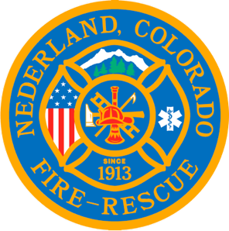

Nederland Fire Protection District Board of Directors Regular Meeting Agenda
August 16, 2023

** This meeting is being recorded **

Roll Call
Guy Falsetti -
Todd Wiesler –
Russ Panneton -
Bob Sheehan
Ryan Keeler

Interim Chief Schmidtmann -Y

Announce Quorum & Call Meeting to Order @

Public Statements, Comments or Questions
(Please state name and if in district or out of district for the record)
Name District

Approve the meeting agenda

Acceptance of previous meeting minutes

Treasurer’s Report

Chief’s Report

Old Business
Fire Chief Job Search

New Business
Golden Coin for an excellent job done.

Special Executive Session

Special Meeting Conclusions

Public Statements, Comments or Questions
(Please state name and if in district or out of district for the record)

Any other business

Next Meeting September 20th @ 7pm

Adjourn the meeting @

