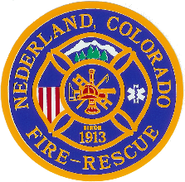 | Nederland Fire Protection District
Board of Directors Meeting
March 4th, 2020

DUE TO THE PANDEMIC OUTBREAK OF COVID19 AND STAY AT HOME ORDERS, THE REGULARLY SCHEDULED NFPD BOARD OF DIRECTORS MEETING SCHDULED FOR APRIL 1st, 2020, WAS CANCELLED

